Assignment-1 CIT/ITI-3250 Business Analytics and Intelligence

1. (50 points) The purpose of this assignment is to give the student an idea of how this course will enhance understanding of business analytics and intelligence, primarily through advanced features Microsoft ® Excel.

This course requires *Microsoft ® Office 2016* or newer.

1. See *Appendix A: Basics of Excel* in Blackboard Resources to review
2. Read sections 10.1 and 10.2 from Chapter 10 of the textbook
3. Apply sections 10.1 and 10.2 to Problem #1 (a-d) into your "working" spreadsheet
4. Complete Problem #2 (a-b) in your "working" spreadsheet (answers provided below)
5. Each assignment in this course will contain two files you must turn in for grading:
   1. The .xlsx file from the textbook publisher that contains the starting raw data. This then becomes your "working" spreadsheet that you must also turn in for grading. It is data and graphs from this file that will be copied to the .docx file as you see fit.

NOTE: For this Assignment-1, the starting file will be *CoxElectric.xlsx*

* 1. The .docx file contains your answers to the questions in the textbook. You can copy any information from the spreadsheet and add explanatory information to answer the specific question asked in the assigned textbook problem.

NOTE: For this Assignment-1, the working spreadsheet will be *CoxElectric.docx*

Submit: Files called *CoxElectric.xlsx and CoxElectric.docx* to Blackboard.

PLEASE READ: Below you see significant progress toward the completion of problem #1 (a-d) and problem #2 (a-b) from the problems at the end of Chapter 10 of the textbook. This is not intended to be difficult or confusing, but rather to get the student into the tools and procedures of the course. By reading the chapter sections and observing the answers or partial answers below, you should be able to proceed easily. NOTE: 1.a and 1.b are completed below. You will complete 1.c, 1.d, 2.a, and 2.b using the hints provided below.

1. a.

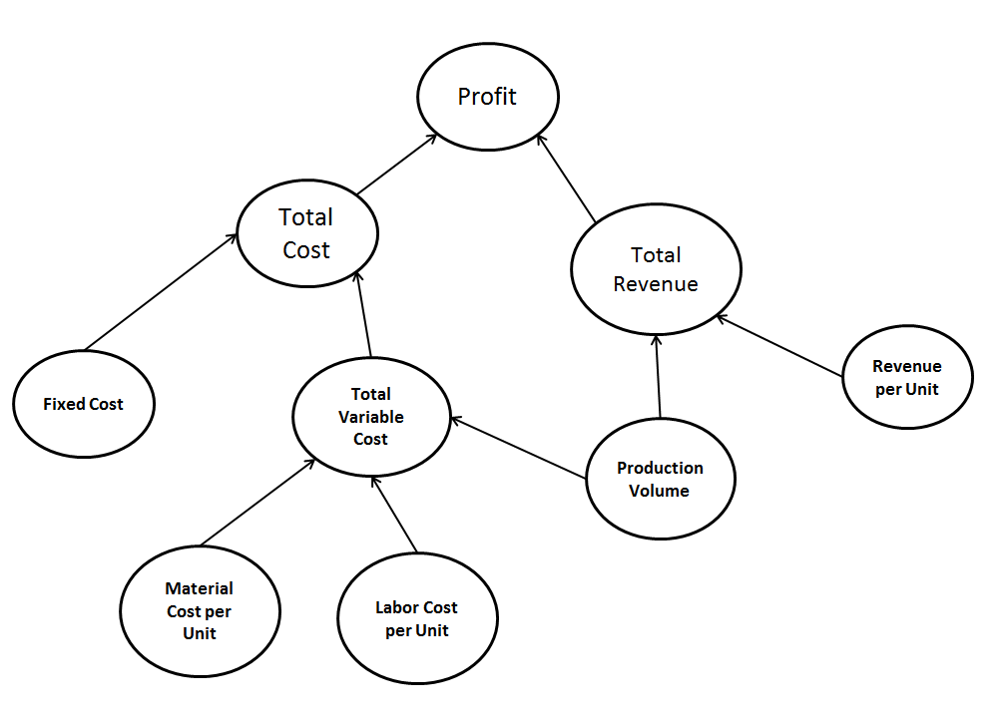

b. Let q = production volume (quantity produced)

R = revenue per unit

FC = the fixed costs of production

MC = material cost per unit

LC = labor cost per unit

P(q) = total profit for producing (and selling) q units



c.

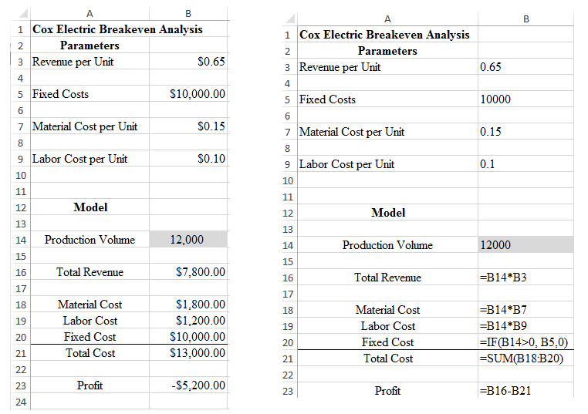

d. Profit of -$5,200 is earned from a production volume of 12,000.

1. a.

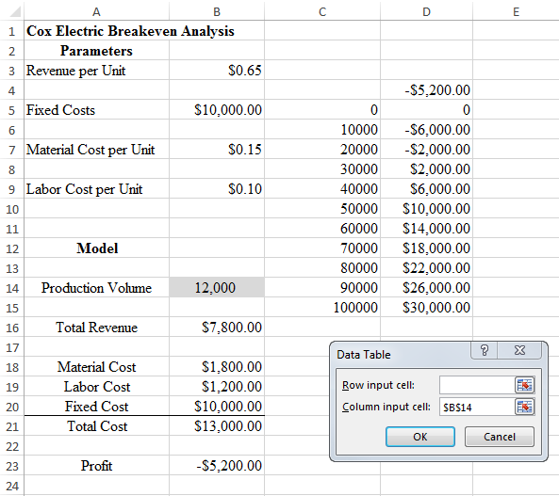

Breakeven appears in the interval of 20,000 to 30,000 units.

b.

